EDC & Institute’s Innovation Council (IIC)
Academic Year 2017-2018
S.No. | Date | Name of the event | No of Participants | Resource Person | Images
 | 01.03.2018 | Workshop on Empowerment of Entrepreneurship and Skill | 200 | Mr.A.DIN.PONGOTRA, Chief Mentor, National Entrepreneurship Development Centre (NEDC) Noida. | 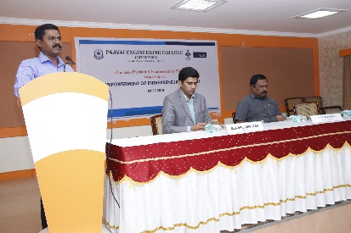
 | 15.03.2018 | Inaugural of Business Incubation Centre (Ministry of Micro, Small and Medium Enterprises) | 150 | Shri. D. Ravichandar, Chief Executive Officer, JSW Steel Ltd, Salem  Shri.K.Sivarama Prasad, Assistant Director, MSME Development Institute, | 