**PAAVAI ENGINEERING COLLEGE (AUTONOMOUS)**

**4.3.1 IT Facilities:**

The Institution provides IT enabled teaching-learning environment in the campus round the clock. Leased web connectivity is in place to cater to all students and staff through Wi Fi and physical connectivity. Continuous up gradation of technology and the infrastructure is one of the quality policies of the institution***.***

The college has campus network and Wi-Fi facility with around 1000 nodes. Fiber optic cables are available for faster and efficient connectivity. Old and outdated computers are upgraded periodically. They are either replaced or enhanced with respect to configuration. Additional computing facilities are added based on the need arising out of requirements of students, research scholars and faculty.

Computer lab is well-equipped with branded PC's adequately supported by 1 Gbps leased lines for internet connectivity. It is also equipped with a wide range of licensed system software and application software. The entire campus is connected with LAN Messenger. Computer labs are well connected to the internet, help students and faculty to carry out their academic and other work. Lab assistants are available to support students and faculty in their queries. The Institute has total 1125 computers.

Core layer switches in the buildings are connected with the Optical Fiber Ring Network (1.5Km Ring). This core switching is further extended to Distributed Switching for departments. Where 100/1000 Mbps (Gigabit Switches) are installed. As per the requirements of access point 10/100 (Megabits) or 100/1000 (Gigabit Switches) are used.

**OFC RACK :**

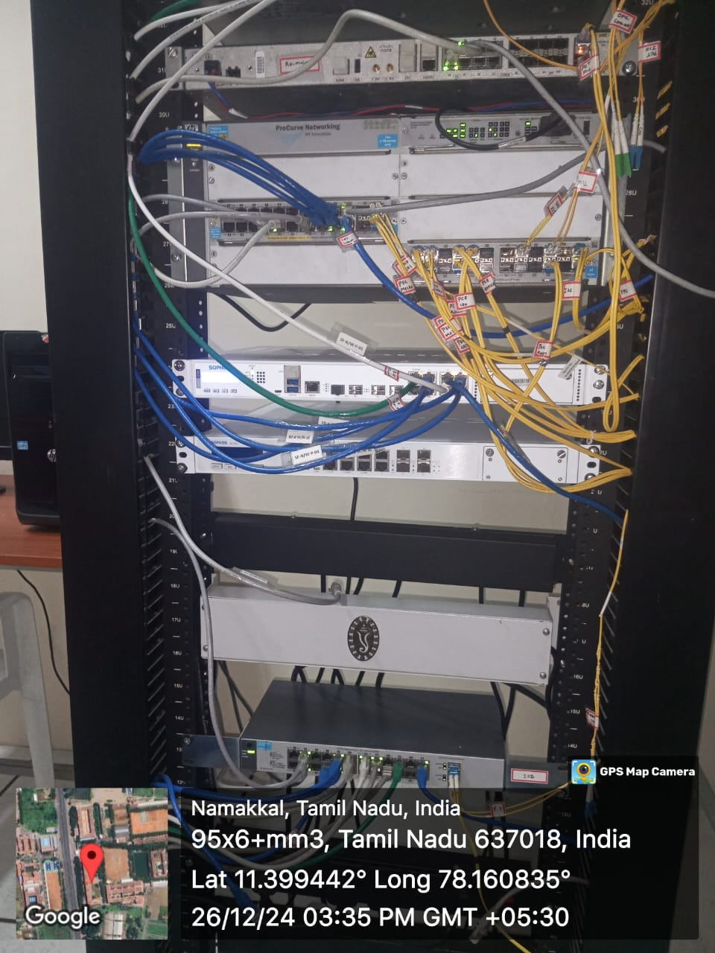

**RACK SERVER:**

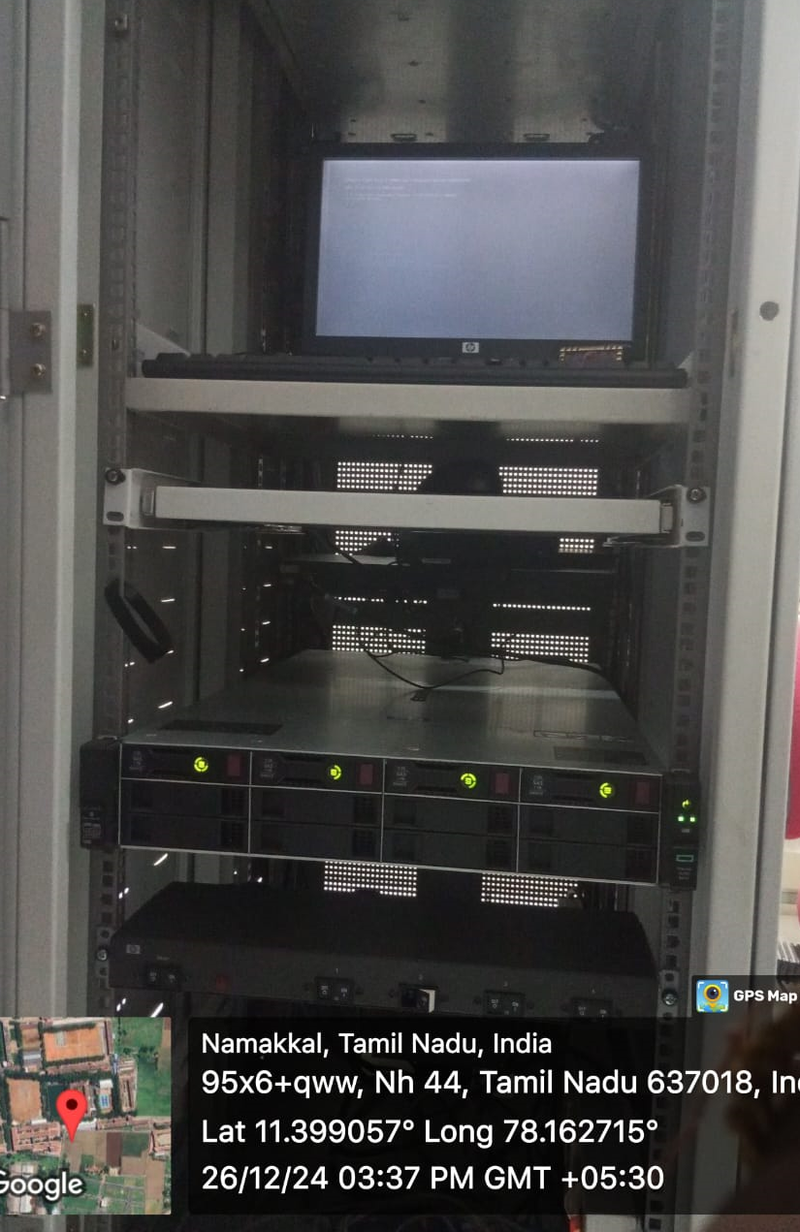

**JIO Wi-Fi Rack & Manageable Switch:**

