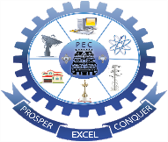
PAAVAI ENGINEERING COLLEGE
(Autonomous)
ENTREPRENEURSHIP DEVELOPMENT CELL
Activities 2022-2023

NEP 2020 -Inaugural Address Session. Seminar -Startup -Legal and Ethical steps.
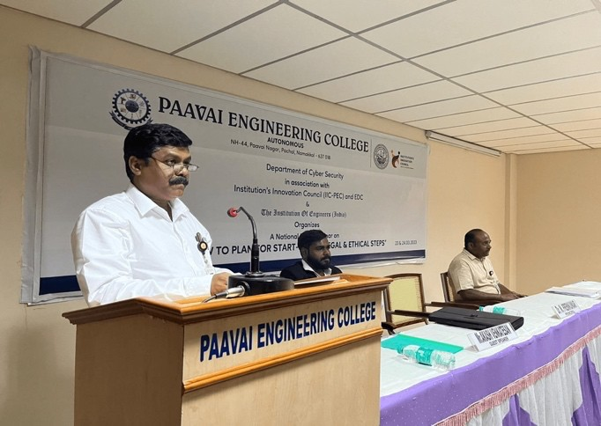
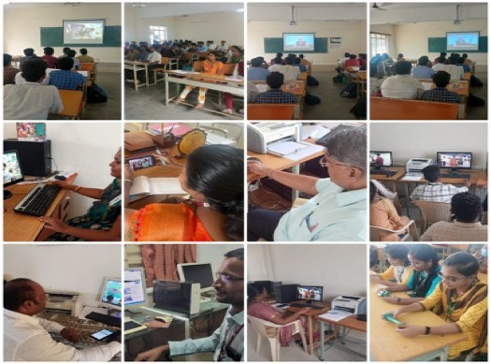

Idea Validation Bootcamps

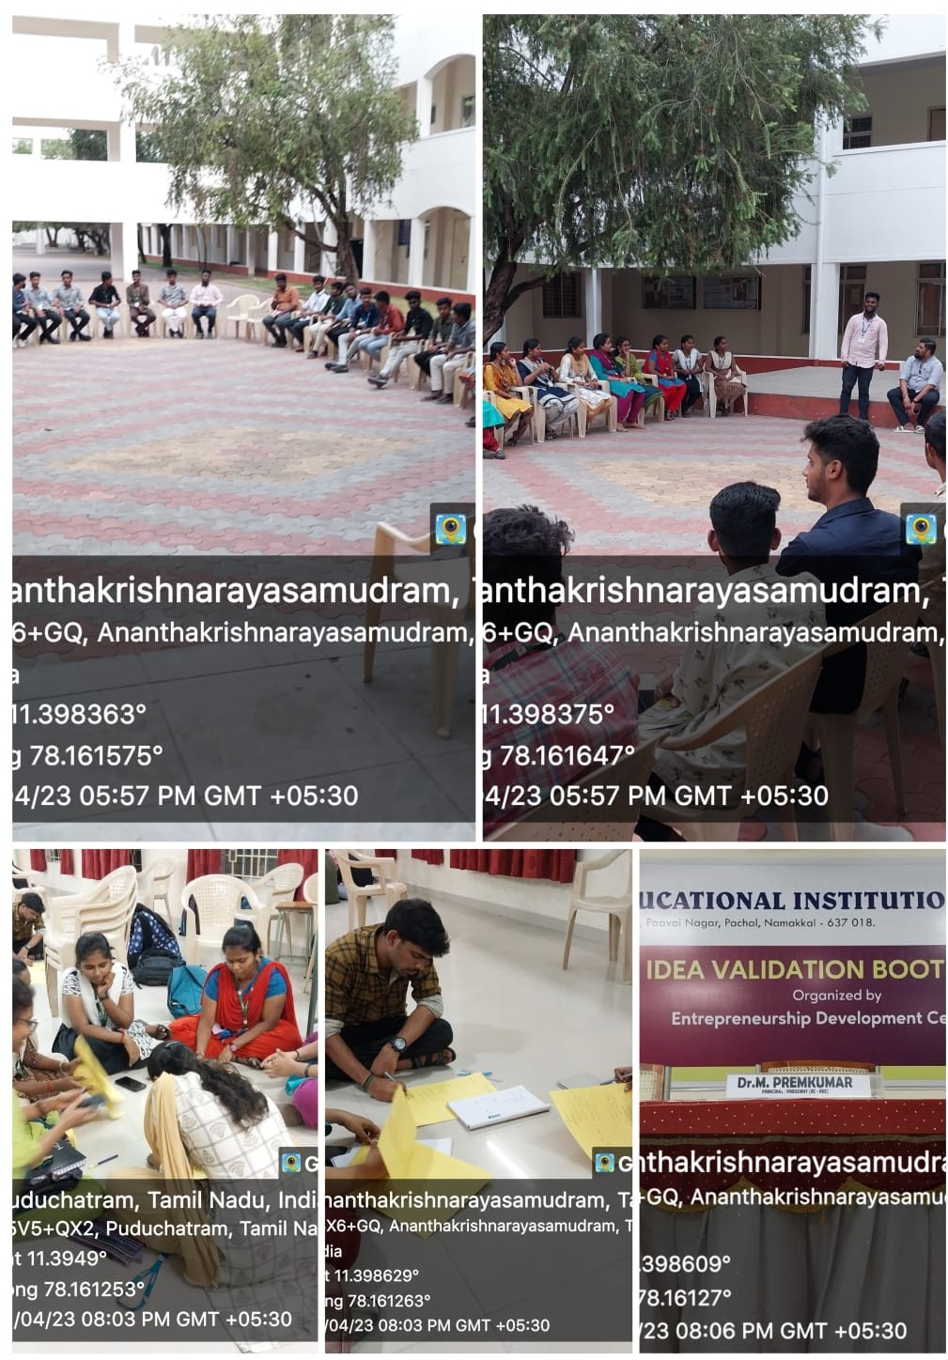

Exposure visit to incubation centre at

SASTRA & Indian Institute of Food Processing Technology

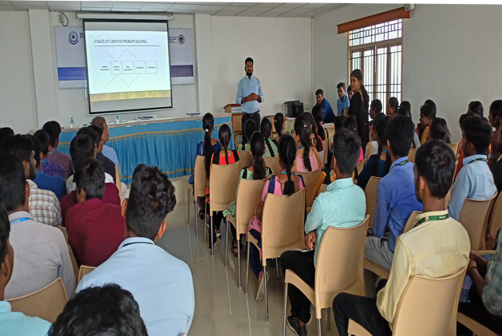
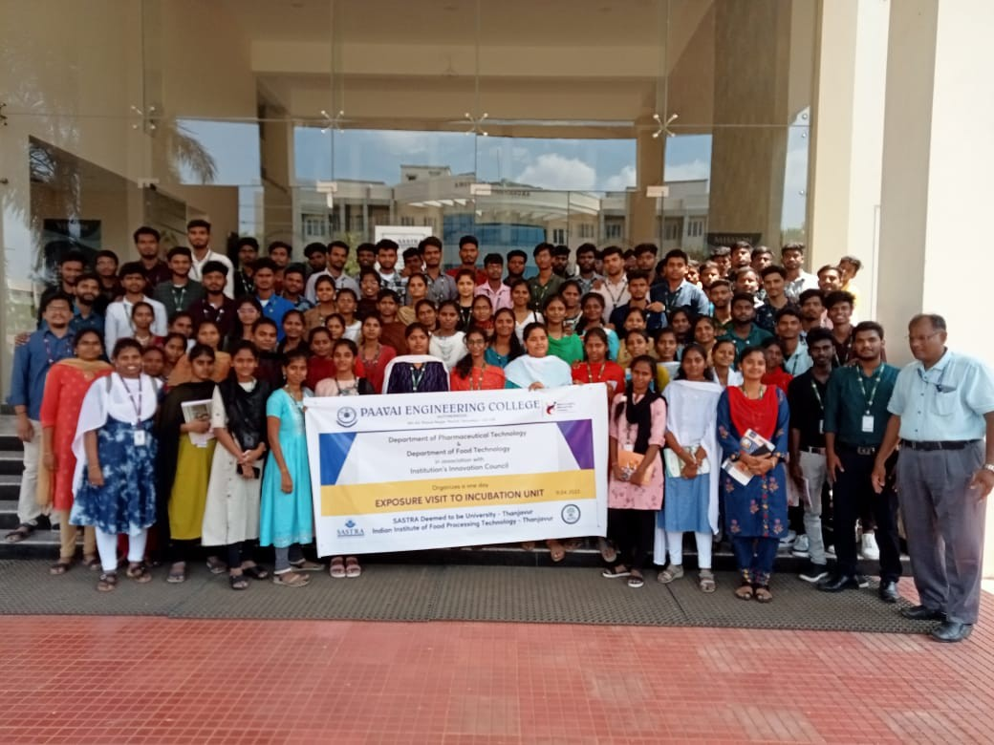

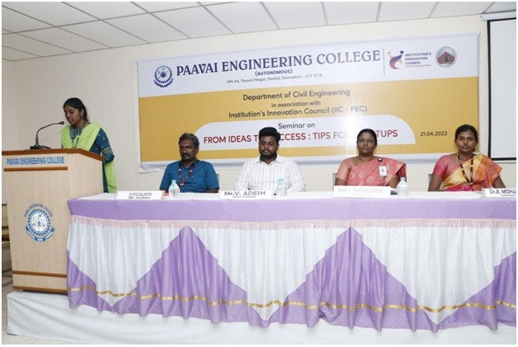

Tips for Start-up -Seminar

MSME Women Hackathon 3.0 Glimpses.
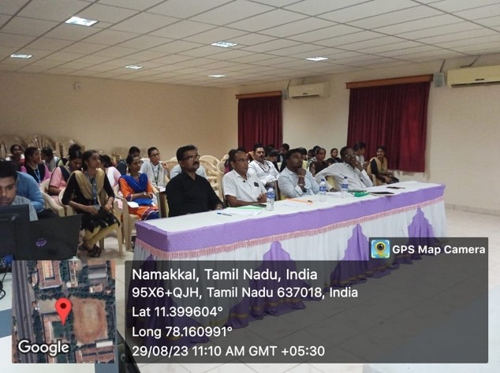
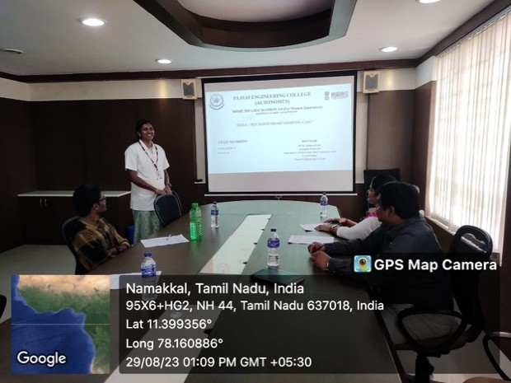

Commercialisation of Lab Technologies Workshop
Project Presentation of Innovations
